2-Aug-2025

(7.15 pm) When ‘Confirm’ button on Details screen is clicked, it navigates to the following screen and displays the error ‘Internal Server Error’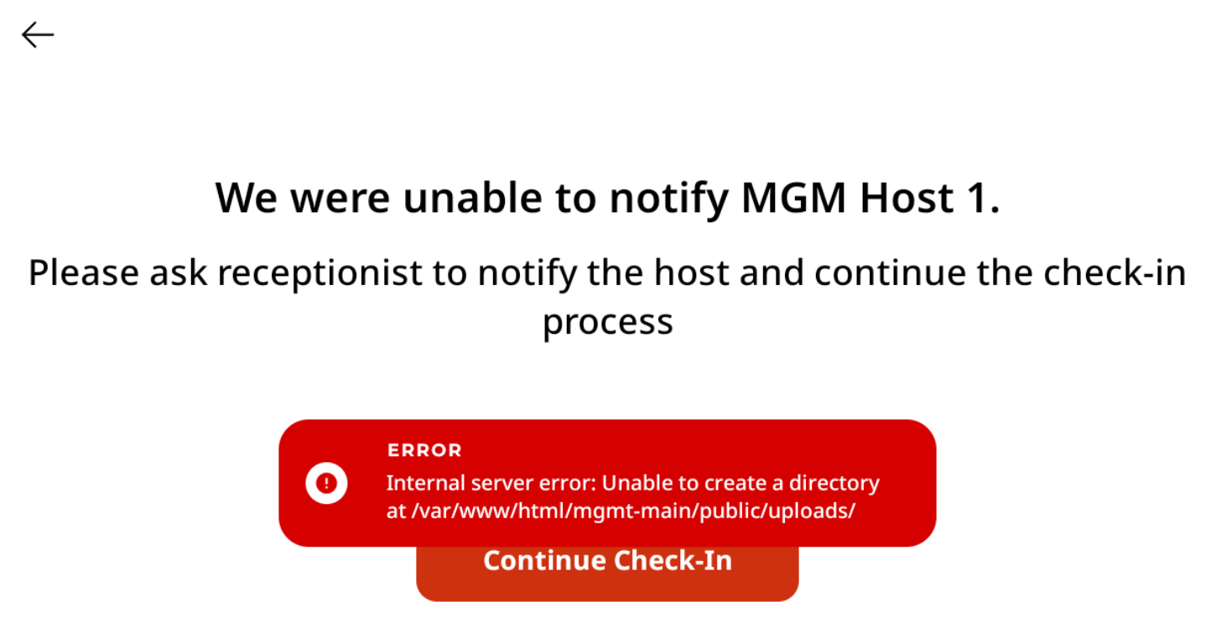

(9.53 pm) After the folders were created:

